

CAPSTONE PROJECT REPORT
Report 4 – Software Design Document

– Hanoi, August 2019 –

Table of Contents
I. Record of Changes 3
II. Software Design Document 4
1. System Design 4
1.1 System Architecture 4
1.2 Package Diagram 4
2. Database Design 4
3. Detailed Design 5
3.1 <Feature/Function Name1> 5
3.2 <Feature/Function Name2> 6

I. Record of Changes
Date | A, M, D * | In charge | Change Description
16/10/2016 | A | Tran Ngoc Khiet | Version 1.0  Add:  - 3. Detailed Design
17/10/2016 | A | Tran Ngoc Khiet | Version 1.1  Add:  - 1.1 System Architecture
*A - Added M - Modified D - Deleted

II. Software Design Document

1. System Design

1.1 System Architecture
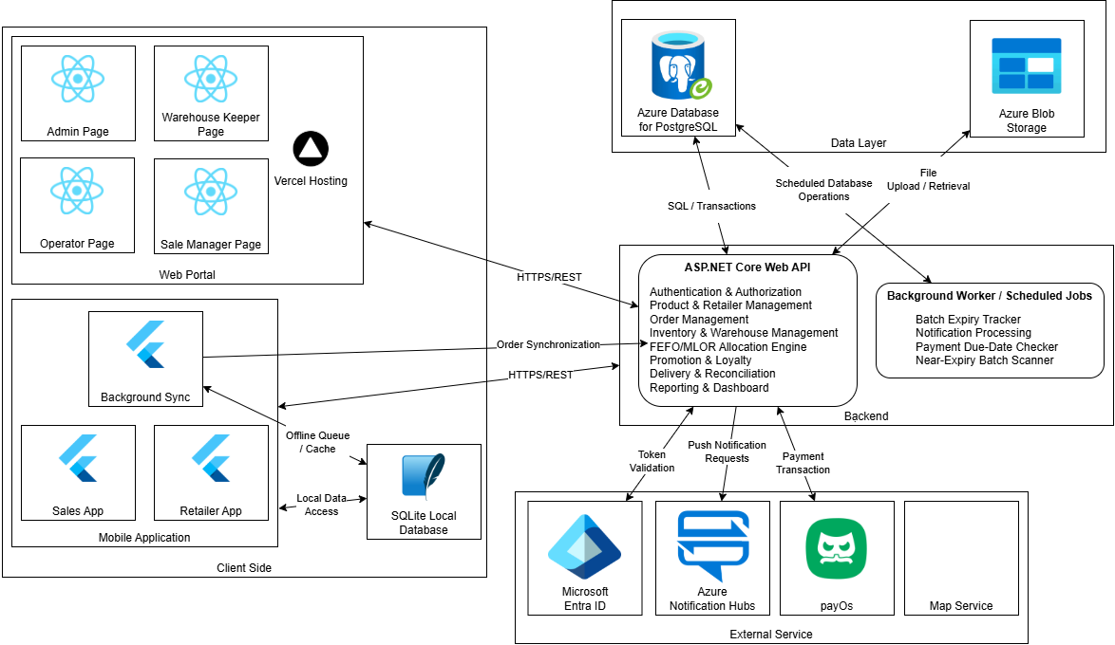
Figure 1. FSCM High-Level System Architecture diagram

1.2 Package Diagram
[Provide the package diagram for each sub-system. The content of this section includes overall package diagram(s) and the explanation for each package (or namespace). Please see the sample and description table format below]
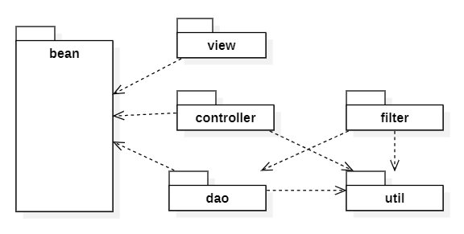
Package Descriptions
No | Package | Description
01 | <Package name> | <Description of the package>
02

2. Database Design
[Provide the files description, database table relationship & table descriptions like example below]
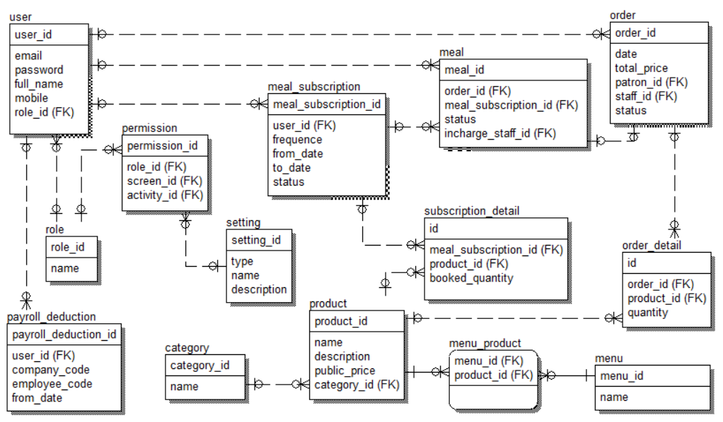
Table Descriptions
No | Table | Description
01 | <Table name> | <Description of the table>  - Primary keys: <<list of primary key fields>>  - Foreign keys: <<list of foreign key fields>>
02 | <Table name2> | …

3. Detailed Design
This section specifies the required UML artifacts for FSCM. Each functional group contains one class diagram and the sequence diagrams needed for materially different workflows. Similar branches are consolidated with UML alt/opt; distinct stock transactions and offline synchronization are kept separate for clarity. Figures are design placeholders until approved UML diagrams are drawn.

3.1 Authentication & User Account

3.1.1 Class Diagram
[Insert Figure 3.1.1 – Authentication & User Account Class Diagram]

3.1.2 Sequence Diagram: User Authentication (System Account / Google Account)
[Insert Figure 3.1.2 – User Authentication (System Account / Google Account) Sequence Diagram]

3.1.3 Sequence Diagram: Manage User Accounts
[Insert Figure 3.1.3 – Manage User Accounts Sequence Diagram]

3.2 Retailer Registration & Assessment

3.2.1 Class Diagram
[Insert Figure 3.2.1 – Retailer Registration & Assessment Class Diagram]

3.2.2 Sequence Diagram: Register Retailer and Collect Assessment
[Insert Figure 3.2.2 – Register Retailer and Collect Assessment Sequence Diagram]

3.2.3 Sequence Diagram: Review Retailer Registration and Assessment
[Insert Figure 3.2.3 – Review Retailer Registration and Assessment Sequence Diagram]

3.2.4 Sequence Diagram: Manage Retailer Profile
[Insert Figure 3.2.4 – Manage Retailer Profile Sequence Diagram]

3.3 Product & Category Management

3.3.1 Class Diagram
[Insert Figure 3.3.1 – Product & Category Management Class Diagram]

3.3.2 Sequence Diagram: Manage Product Category Tree
[Insert Figure 3.3.2 – Manage Product Category Tree Sequence Diagram]

3.3.3 Sequence Diagram: Create and Publish Product
[Insert Figure 3.3.3 – Create and Publish Product Sequence Diagram]

3.3.4 Sequence Diagram: View Product Catalog and Best-Selling Products
[Insert Figure 3.3.4 – View Product Catalog and Best-Selling Products Sequence Diagram]

3.4 Promotion & Batch Discount Management

3.4.1 Class Diagram
[Insert Figure 3.4.1 – Promotion & Batch Discount Management Class Diagram]

3.4.2 Sequence Diagram: Manage Promotion Rules
[Insert Figure 3.4.2 – Manage Promotion Rules Sequence Diagram]

3.4.3 Sequence Diagram: Scan and Apply Near-Expiry Batch Promotion
[Insert Figure 3.4.3 – Scan and Apply Near-Expiry Batch Promotion Sequence Diagram]

3.5 Purchase Order & Offline Synchronization

3.5.1 Class Diagram
[Insert Figure 3.5.1 – Purchase Order & Offline Synchronization Class Diagram]

3.5.2 Sequence Diagram: Create Purchase Order for Retailer
[Insert Figure 3.5.2 – Create Purchase Order for Retailer Sequence Diagram]

3.5.3 Sequence Diagram: Synchronize Offline Purchase Orders
[Insert Figure 3.5.3 – Synchronize Offline Purchase Orders Sequence Diagram]

3.5.4 Sequence Diagram: Process Purchase Order Request
[Insert Figure 3.5.4 – Process Purchase Order Request Sequence Diagram]

3.5.5 Sequence Diagram: Cancel Purchase Order with Evidence
[Insert Figure 3.5.5 – Cancel Purchase Order with Evidence Sequence Diagram]

3.5.6 Sequence Diagram: View Order Status and History
[Insert Figure 3.5.6 – View Order Status and History Sequence Diagram]

3.6 FEFO–MLOR Allocation & Availability

3.6.1 Class Diagram
[Insert Figure 3.6.1 – FEFO–MLOR Allocation & Availability Class Diagram]

3.6.2 Sequence Diagram: Allocate Inventory across Warehouses (including Receipt-Time Estimation)
[Insert Figure 3.6.2 – Allocate Inventory across Warehouses (including Receipt-Time Estimation) Sequence Diagram]

3.6.3 Sequence Diagram: Place Holds and Commit Stock Reservations
[Insert Figure 3.6.3 – Place Holds and Commit Stock Reservations Sequence Diagram]

3.7 Warehouse Receiving & Batch Inventory

3.7.1 Class Diagram
[Insert Figure 3.7.1 – Warehouse Receiving & Batch Inventory Class Diagram]

3.7.2 Sequence Diagram: Create and Process Goods Receipt
[Insert Figure 3.7.2 – Create and Process Goods Receipt Sequence Diagram]

3.7.3 Sequence Diagram: View Warehouse Inventory and Batch Details
[Insert Figure 3.7.3 – View Warehouse Inventory and Batch Details Sequence Diagram]

3.7.4 Sequence Diagram: Manage Warehouse Inventory Write-Off
[Insert Figure 3.7.4 – Manage Warehouse Inventory Write-Off Sequence Diagram]

3.8 Picking & Retailer Receipt Confirmation

3.8.1 Class Diagram
[Insert Figure 3.8.1 – Picking & Retailer Receipt Confirmation Class Diagram]

3.8.2 Sequence Diagram: Scan Batch QR and Confirm Picking List
[Insert Figure 3.8.2 – Scan Batch QR and Confirm Picking List Sequence Diagram]

3.8.3 Sequence Diagram: Confirm Retailer Receipt by QR
[Insert Figure 3.8.3 – Confirm Retailer Receipt by QR Sequence Diagram]

3.8.4 Sequence Diagram: Report Receipt Discrepancy
[Insert Figure 3.8.4 – Report Receipt Discrepancy Sequence Diagram]

3.9 Payment & Loyalty Management

3.9.1 Class Diagram
[Insert Figure 3.9.1 – Payment & Loyalty Management Class Diagram]

3.9.2 Sequence Diagram: Record Order Payment (Cash / QR / Bank Transfer)
[Insert Figure 3.9.2 – Record Order Payment (Cash / QR / Bank Transfer) Sequence Diagram]

3.9.3 Sequence Diagram: View Retailer Loyalty Points
[Insert Figure 3.9.3 – View Retailer Loyalty Points Sequence Diagram]

3.9.4 Sequence Diagram: Redeem Loyalty Reward / Points
[Insert Figure 3.9.4 – Redeem Loyalty Reward / Points Sequence Diagram]

3.10 Sales Groups & Operational Reporting

3.10.1 Class Diagram
[Insert Figure 3.10.1 – Sales Groups & Operational Reporting Class Diagram]

3.10.2 Sequence Diagram: Manage Sales Groups and Coverage
[Insert Figure 3.10.2 – Manage Sales Groups and Coverage Sequence Diagram]

3.10.3 Sequence Diagram: View Sales and Management Dashboards
[Insert Figure 3.10.3 – View Sales and Management Dashboards Sequence Diagram]

3.11 System Configuration & Notifications

3.11.1 Class Diagram
[Insert Figure 3.11.1 – System Configuration & Notifications Class Diagram]

3.11.2 Sequence Diagram: Manage Warehouse Location and Service Configuration
[Insert Figure 3.11.2 – Manage Warehouse Location and Service Configuration Sequence Diagram]

3.11.3 Sequence Diagram: Send Operational Notifications
[Insert Figure 3.11.3 – Send Operational Notifications Sequence Diagram]

3.12 Delivery Operations

3.12.1 Class Diagram
[Insert Figure 3.12.1 – Delivery Operations (PENDING) Class Diagram]

3.12.2 Sequence Diagram: Process Delivery Assignment
[Insert Figure 3.12.2 – Process Delivery Assignment Sequence Diagram]

